Experiment No. 14 20141128

Adding a Worksheet

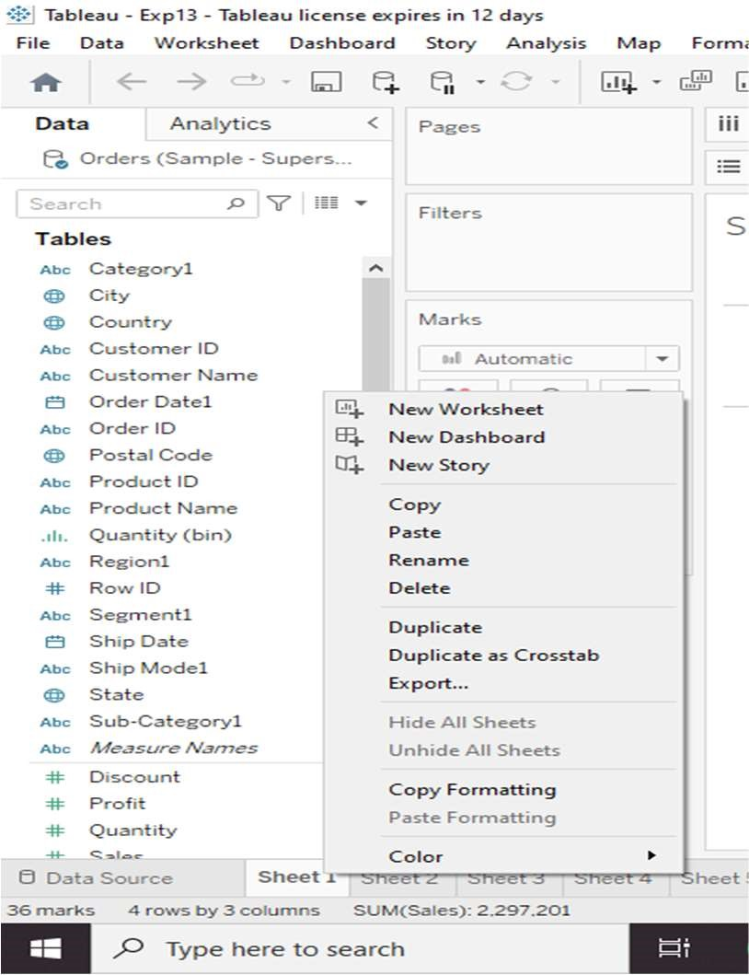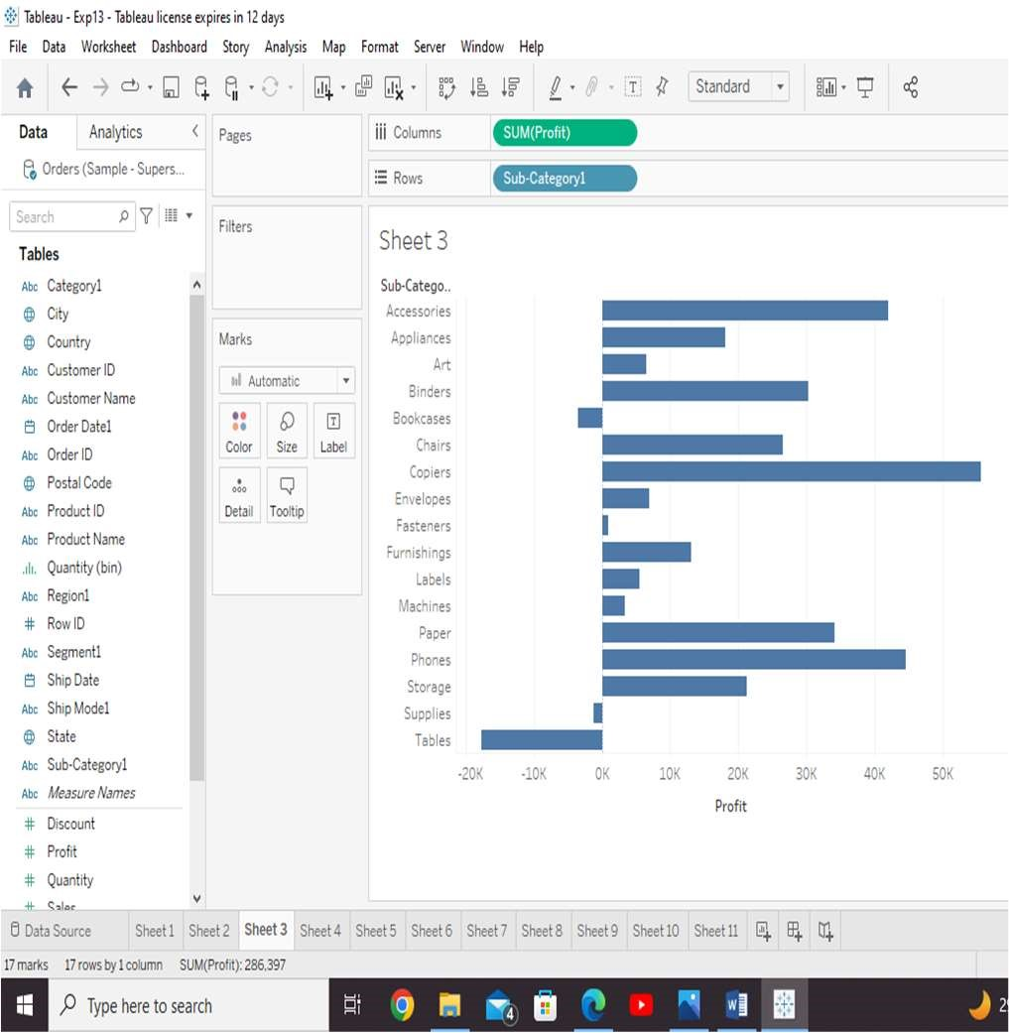

Tableau - Basic Filters

We use the Sample - Superstore data source to apply filters.

Filter Dimensions

The following screenshot shows the result with the two categories excluded.

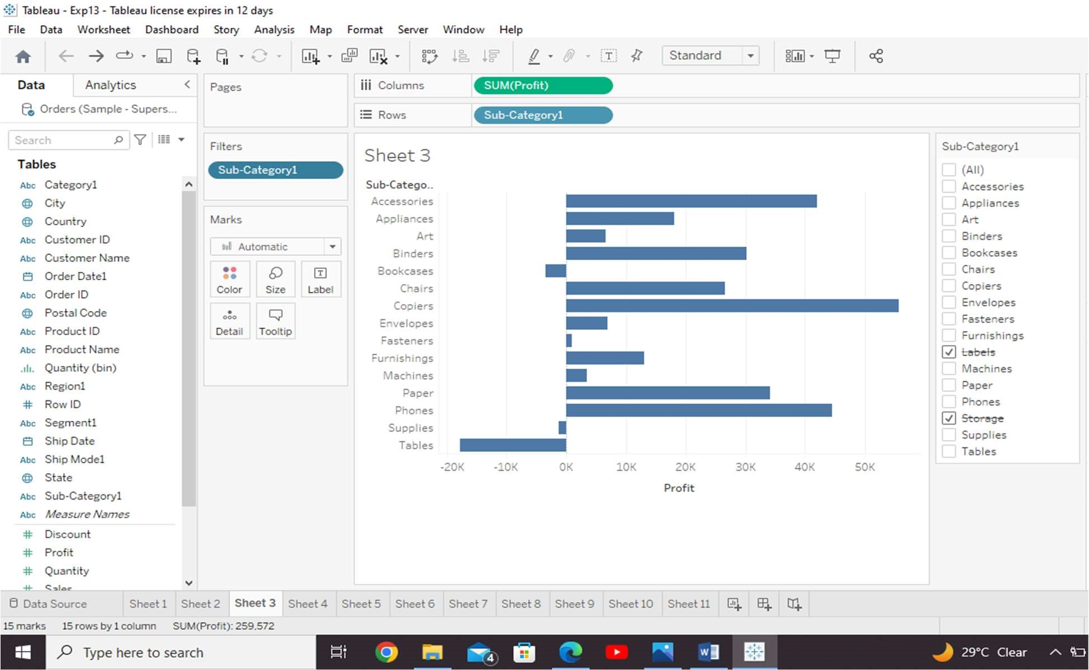

Filter Measures

We get the final view below showing only the subcategories whose average profit is greater than 20.

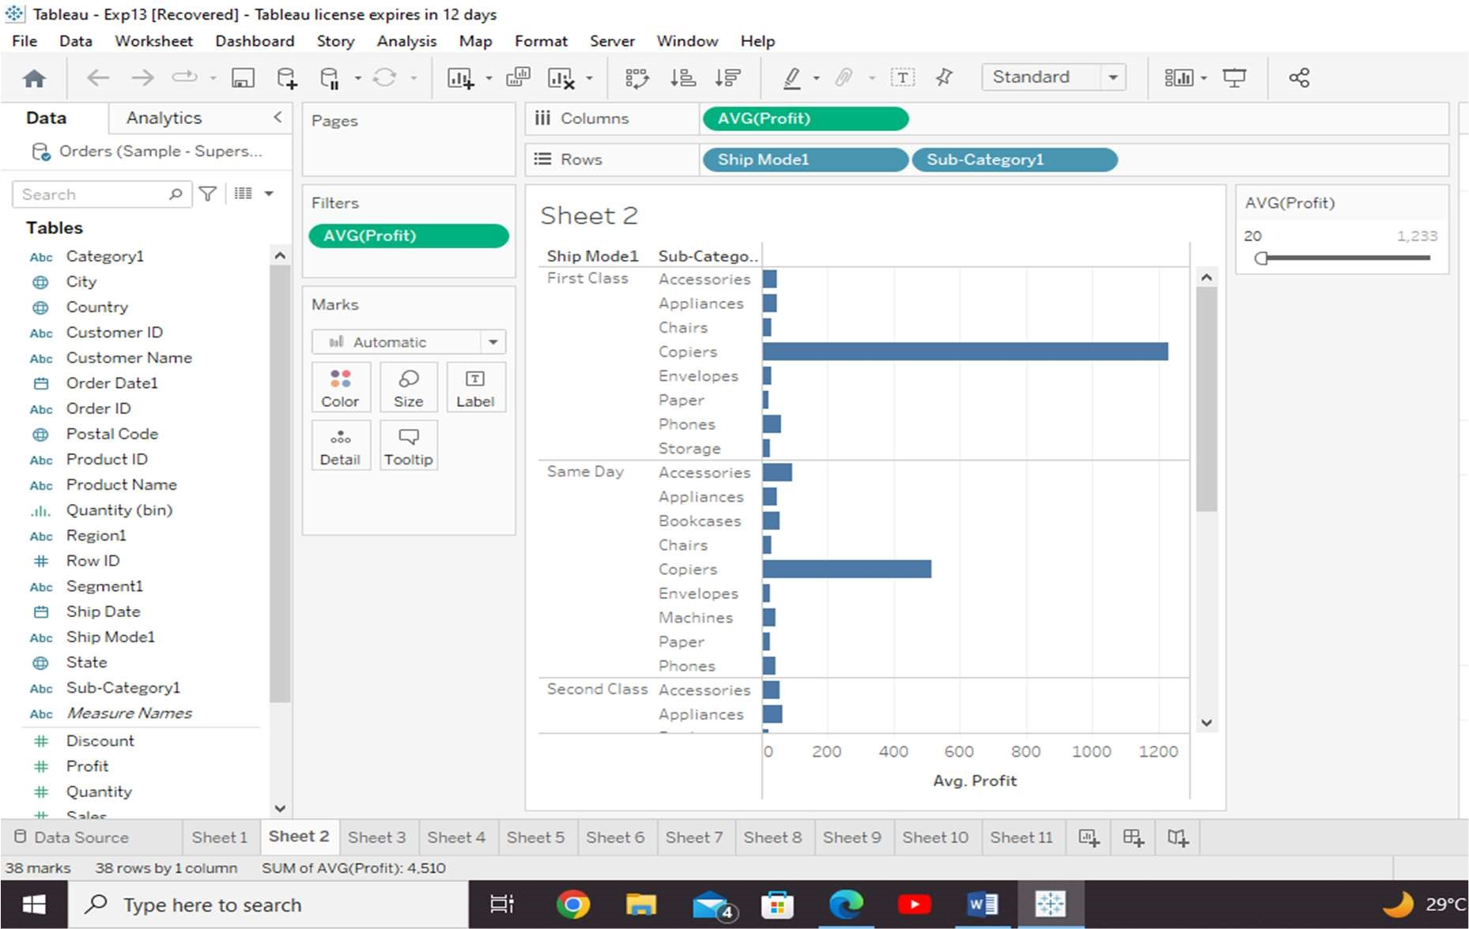

Filter Dates

The final view appears showing the result for the chosen range of dates as seen in the following screenshot.

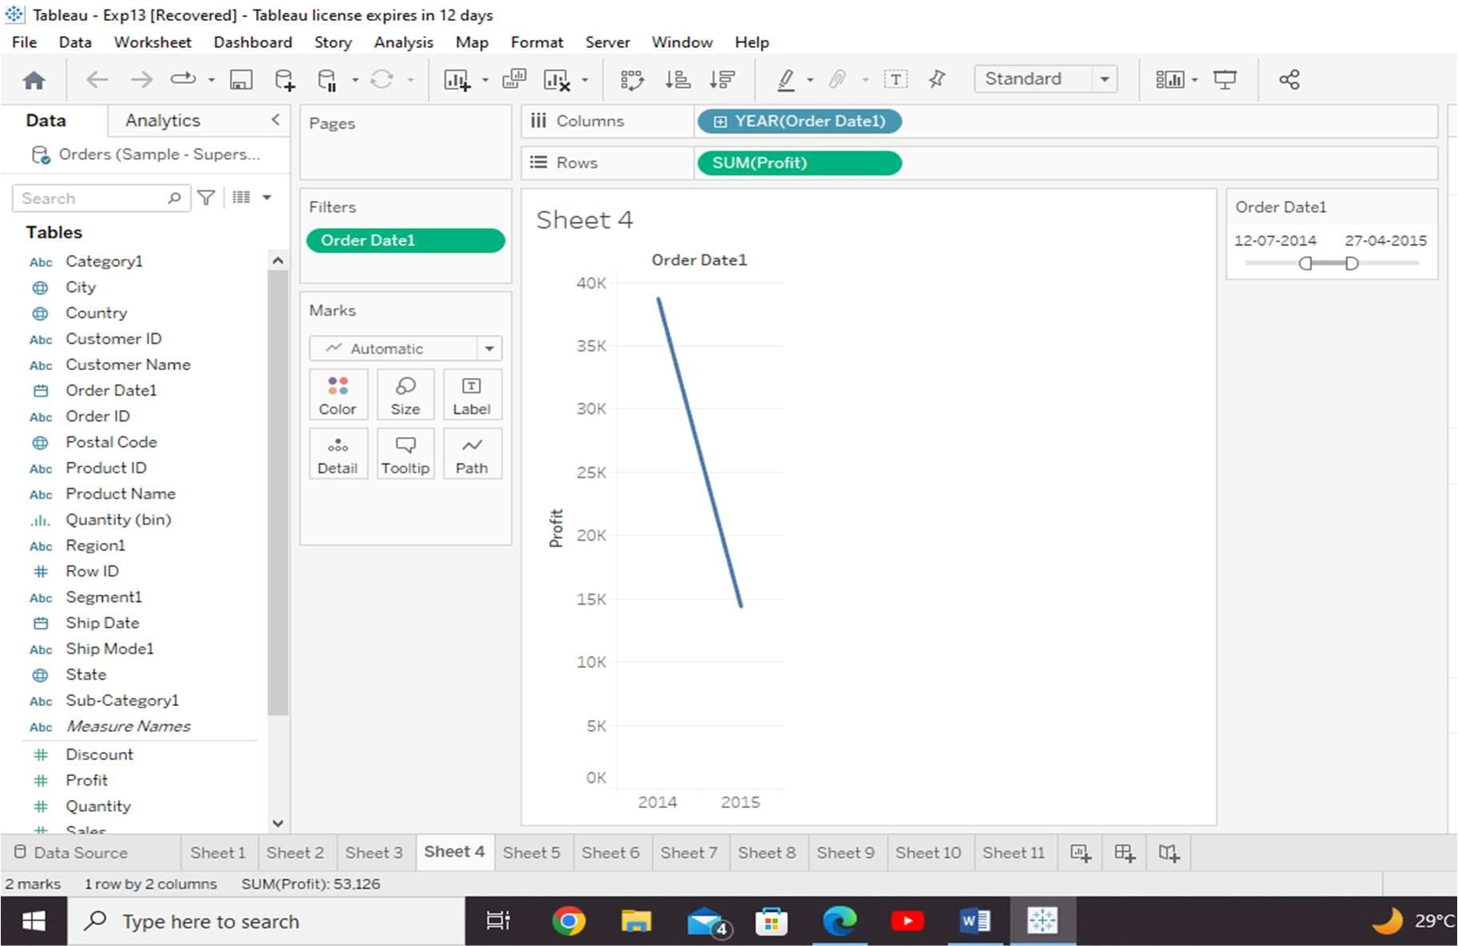

Tableau - Quick Filters

Apply wildcard filtering using the expression a\* which selects all subcategory name starting with “a”.

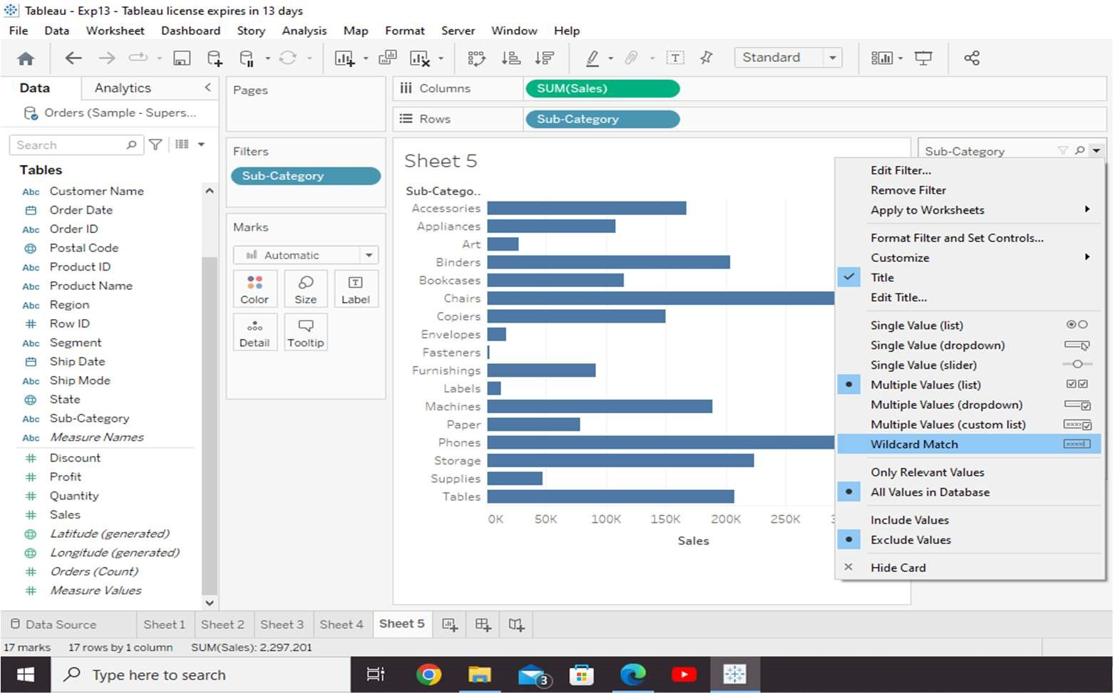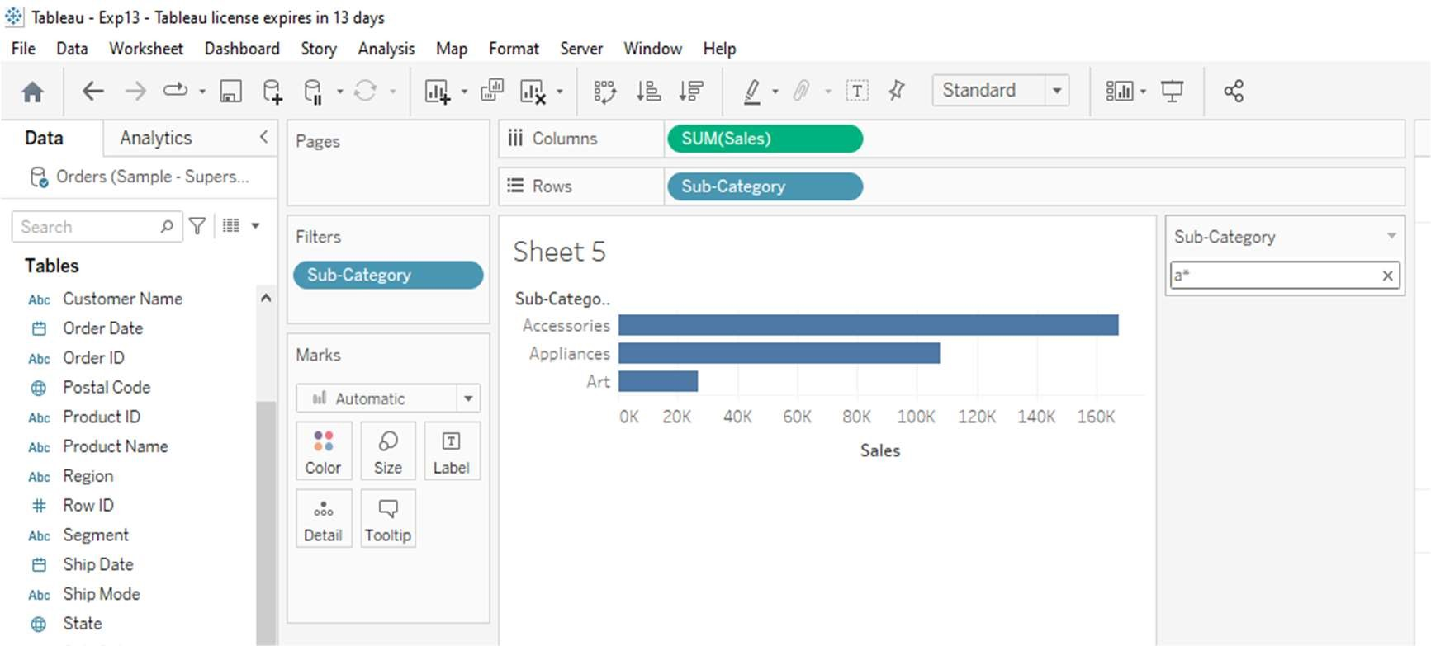

Clearing the Filter.

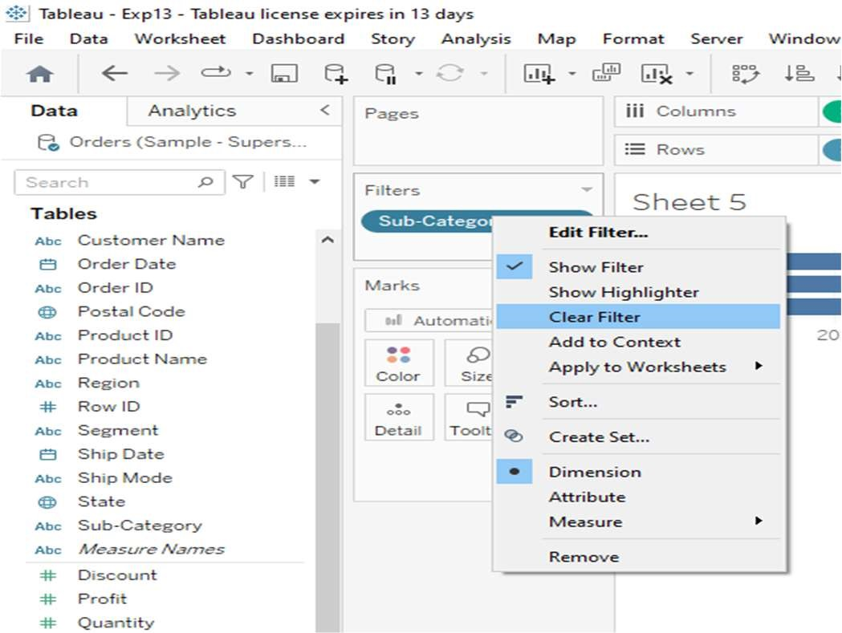

Tableau - Bar Chart

Bar Chart with Colour Range

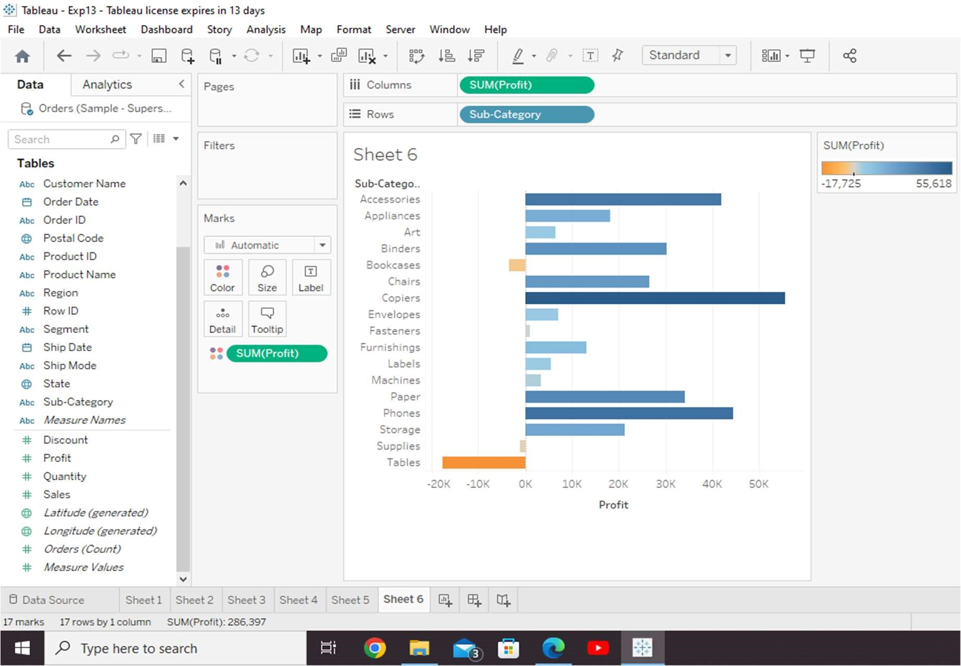

Stacked Bar Chart

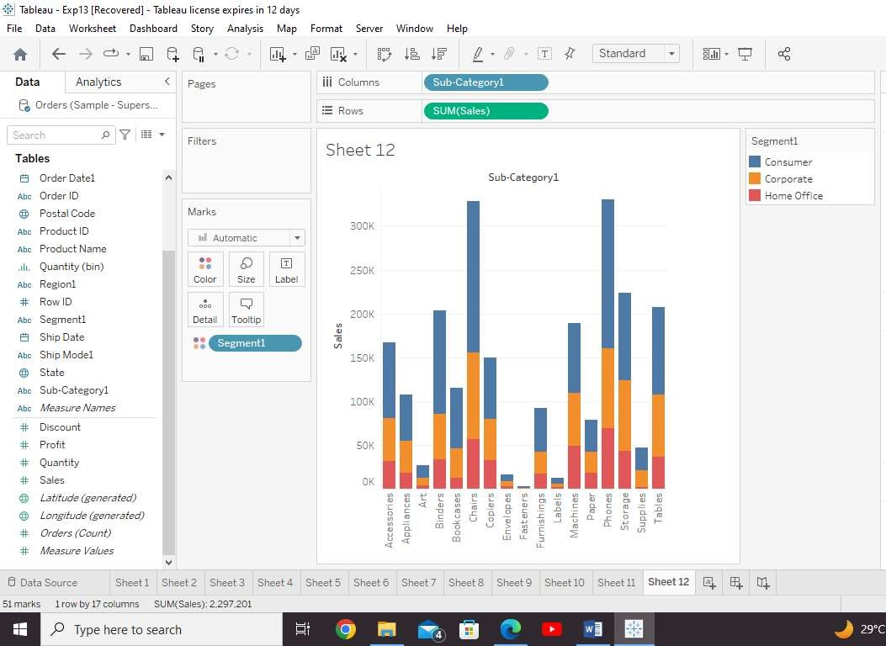

Tableau - Line Chart

Simple Line Chart

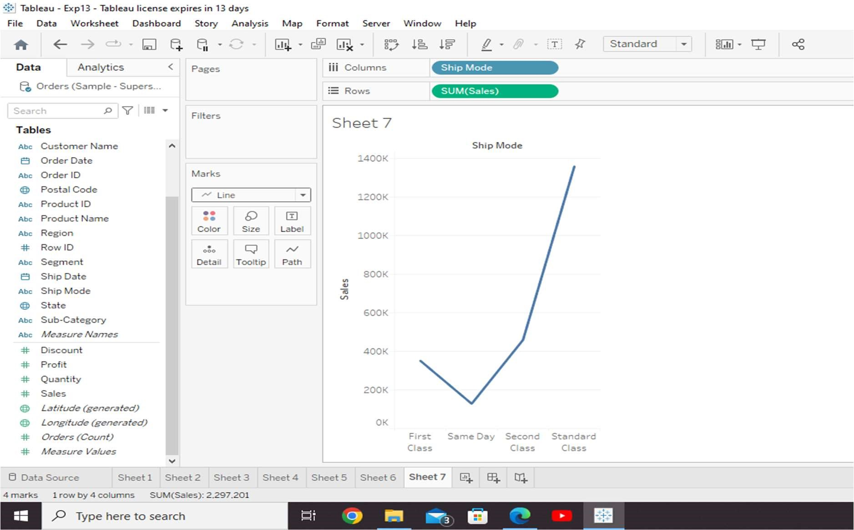

Multiple Measure Line Chart

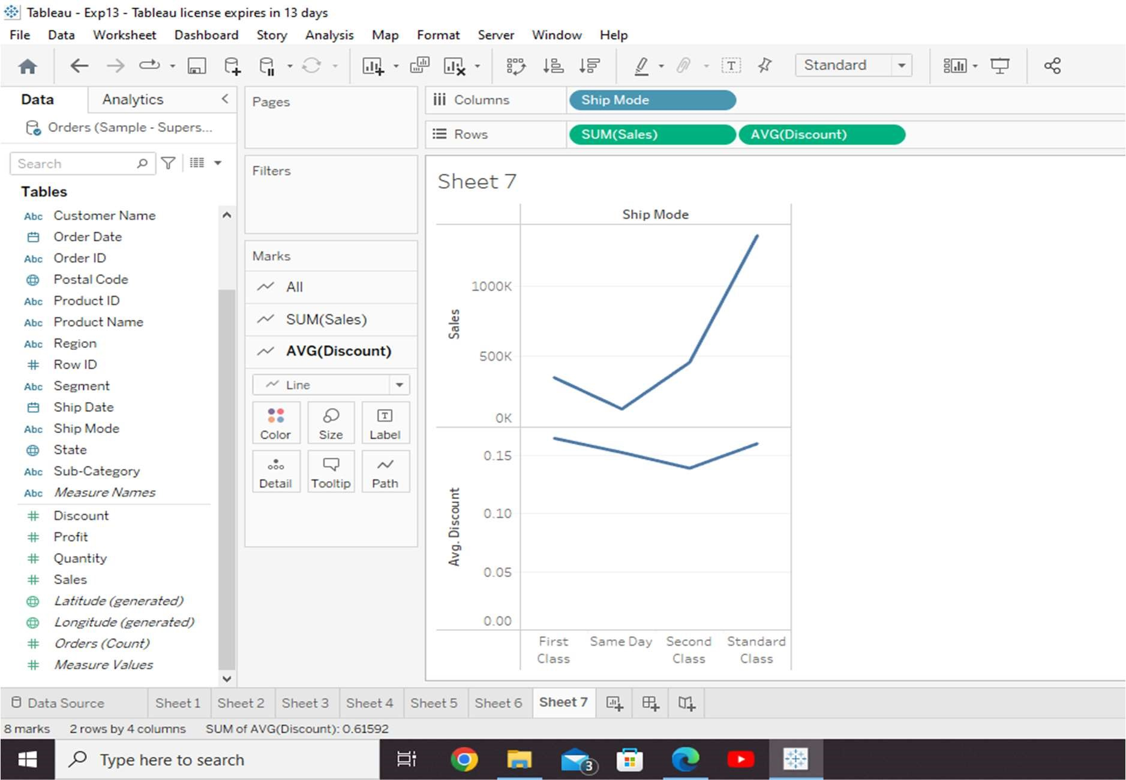

Line Chart with Label

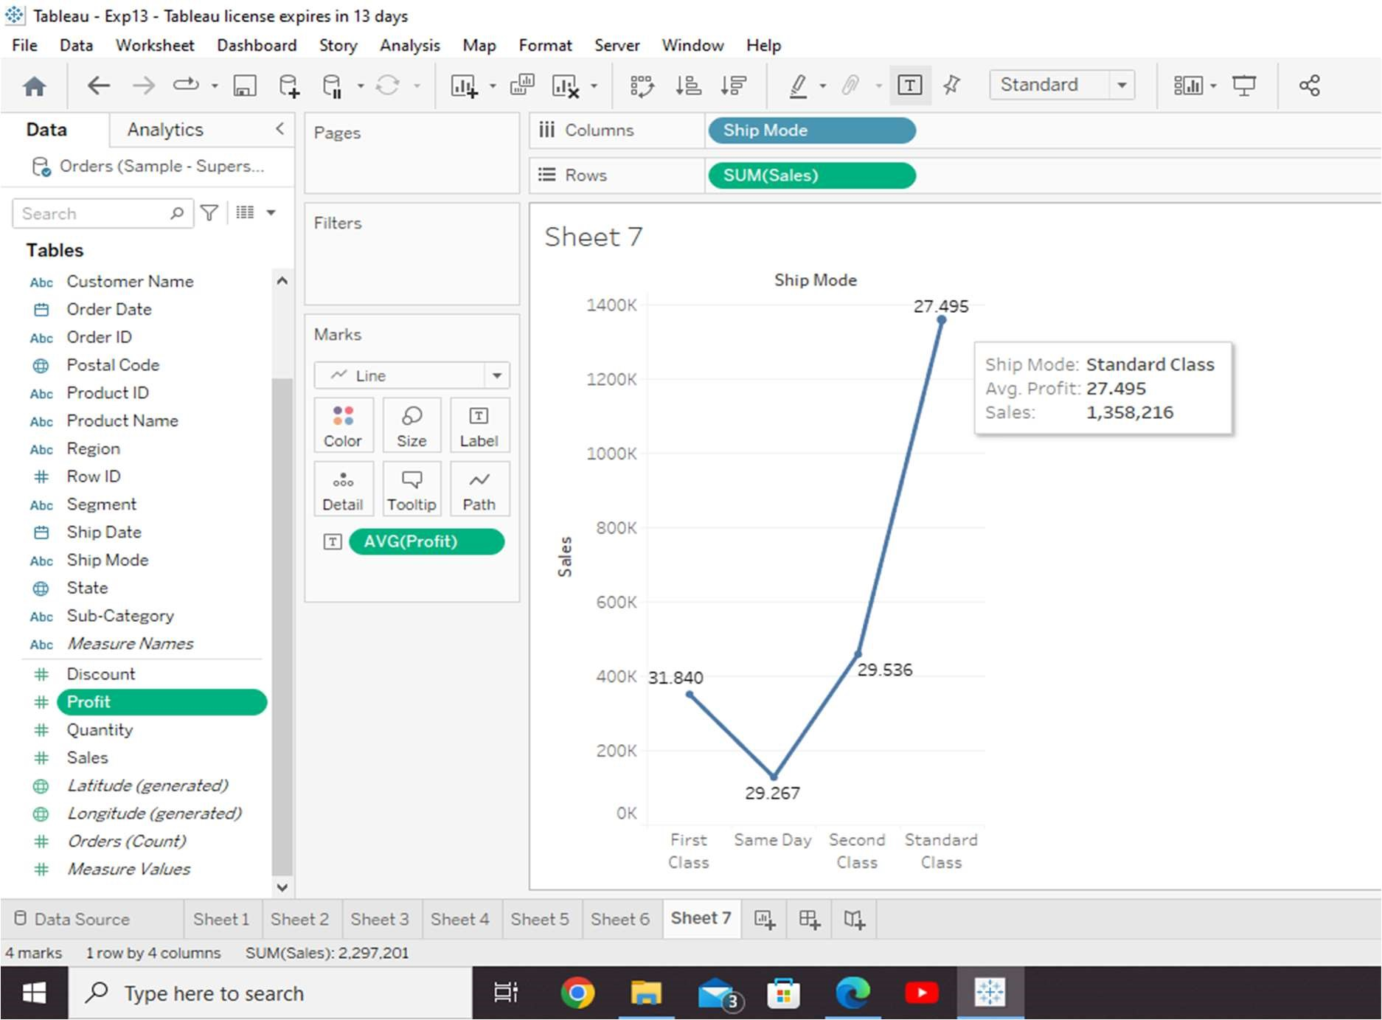

Tableau - Pie Chart

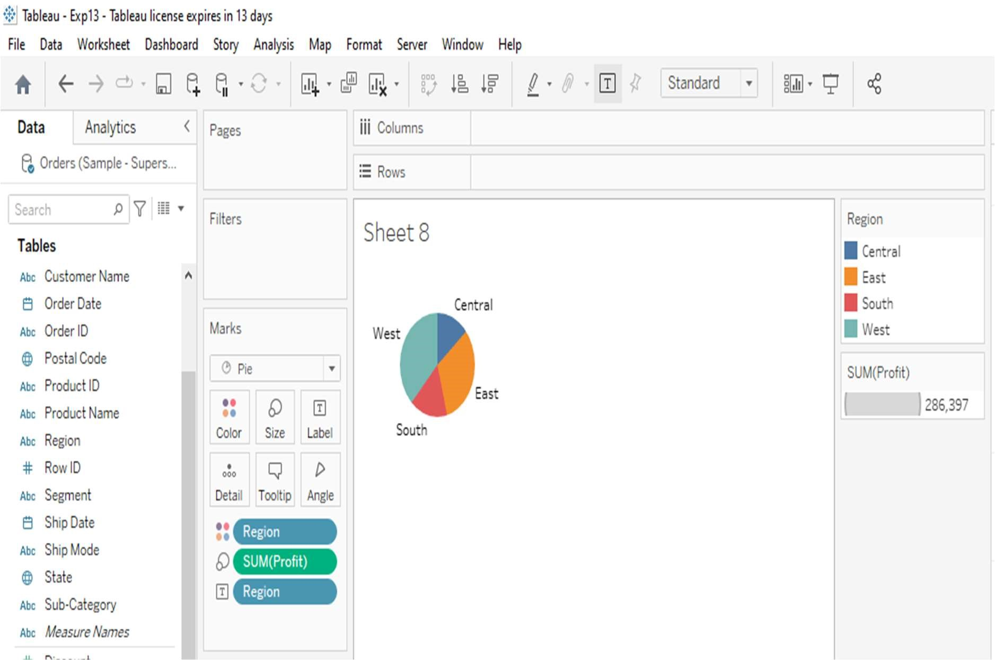

Tableau - Scatter Plot

Simple Scatter Plot

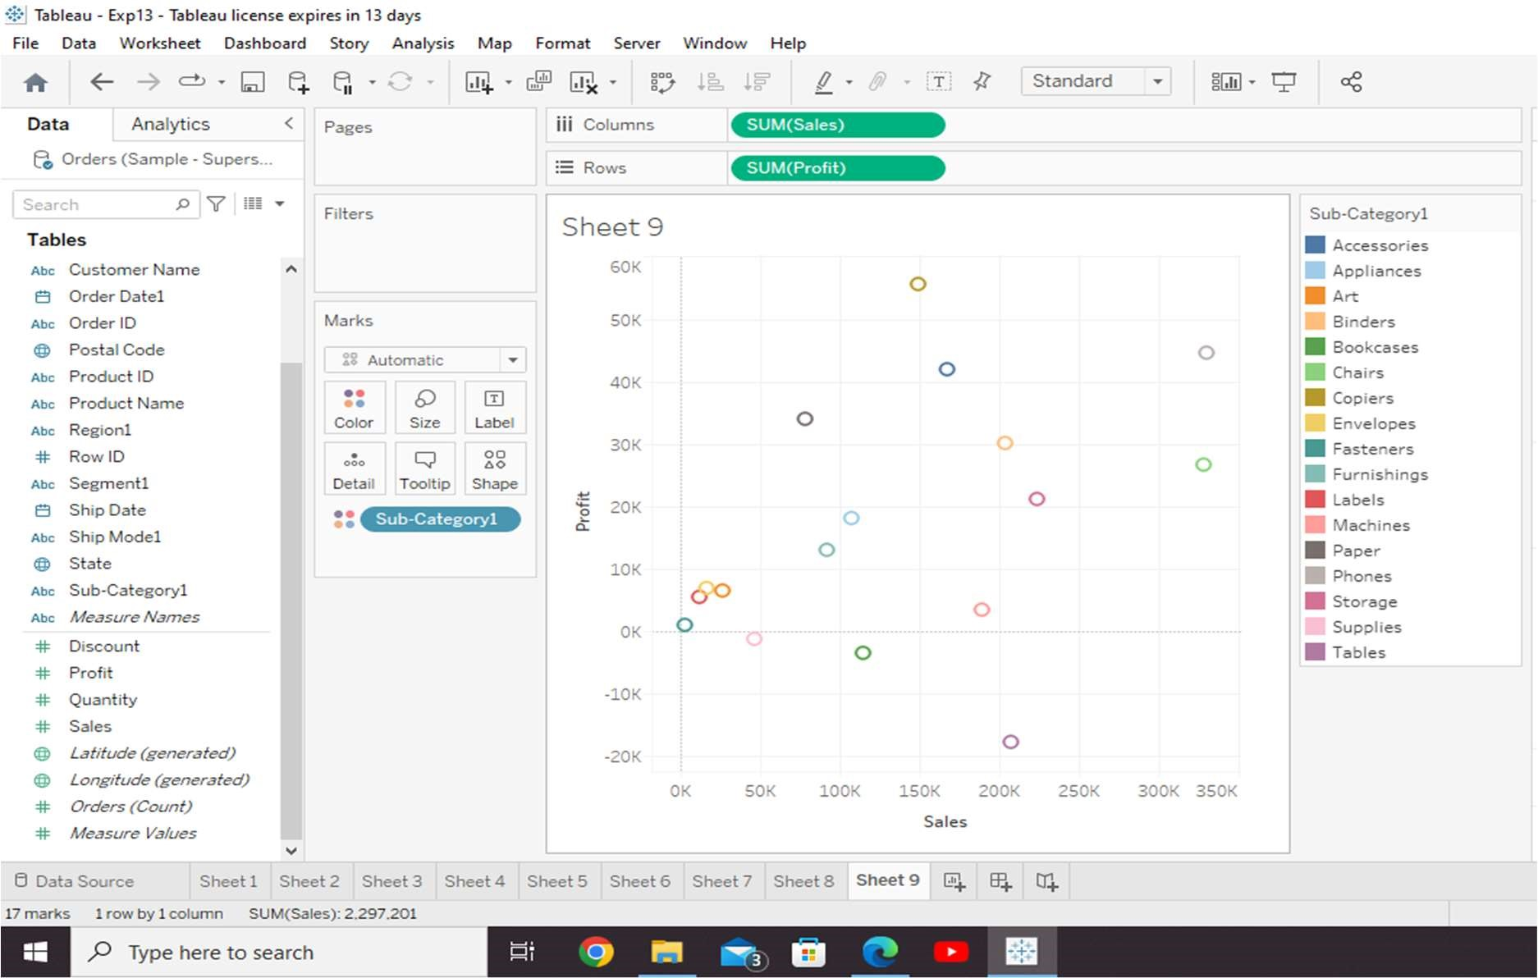

Drill-Down Scatter Plot

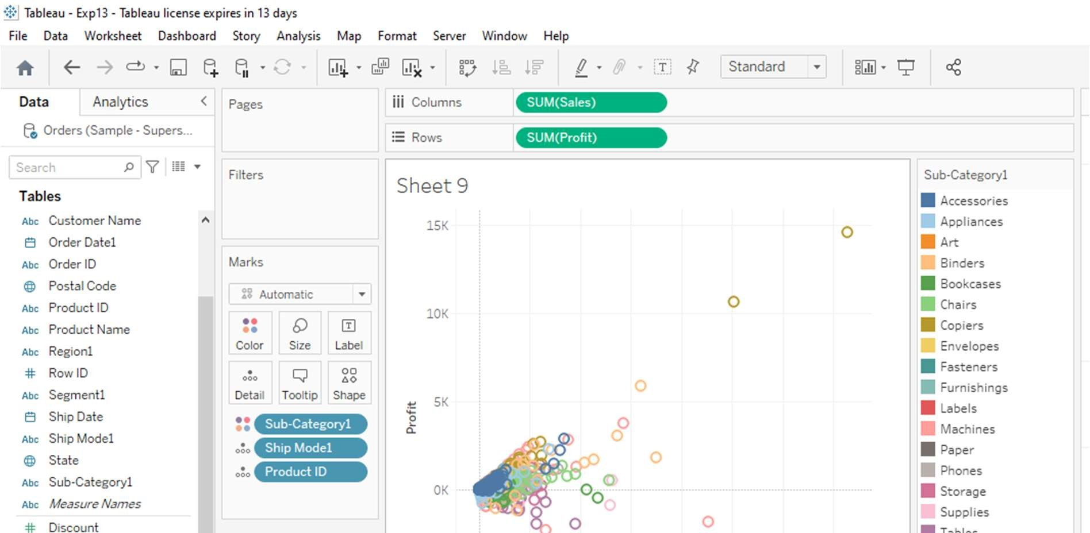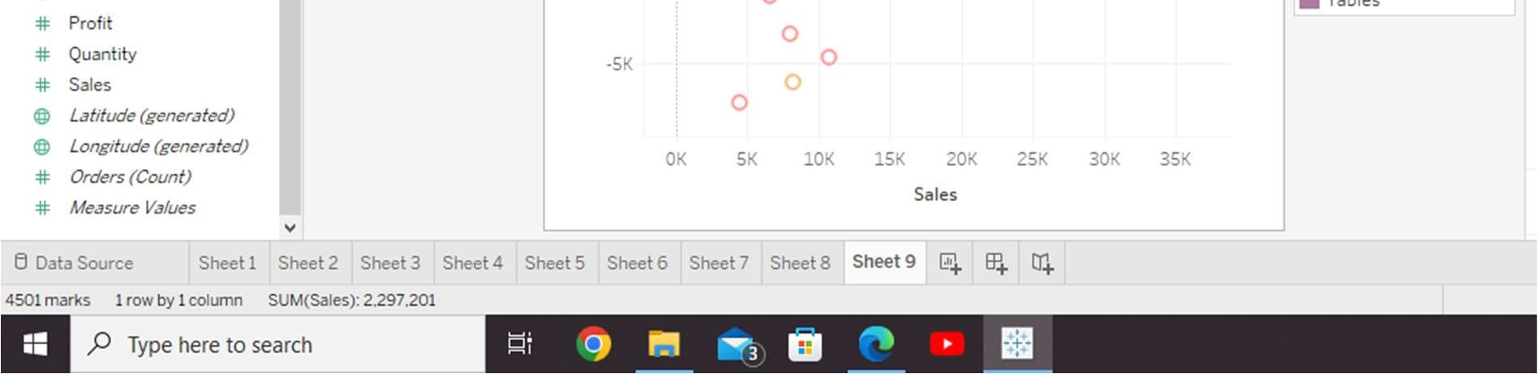

Tableau - Histogram

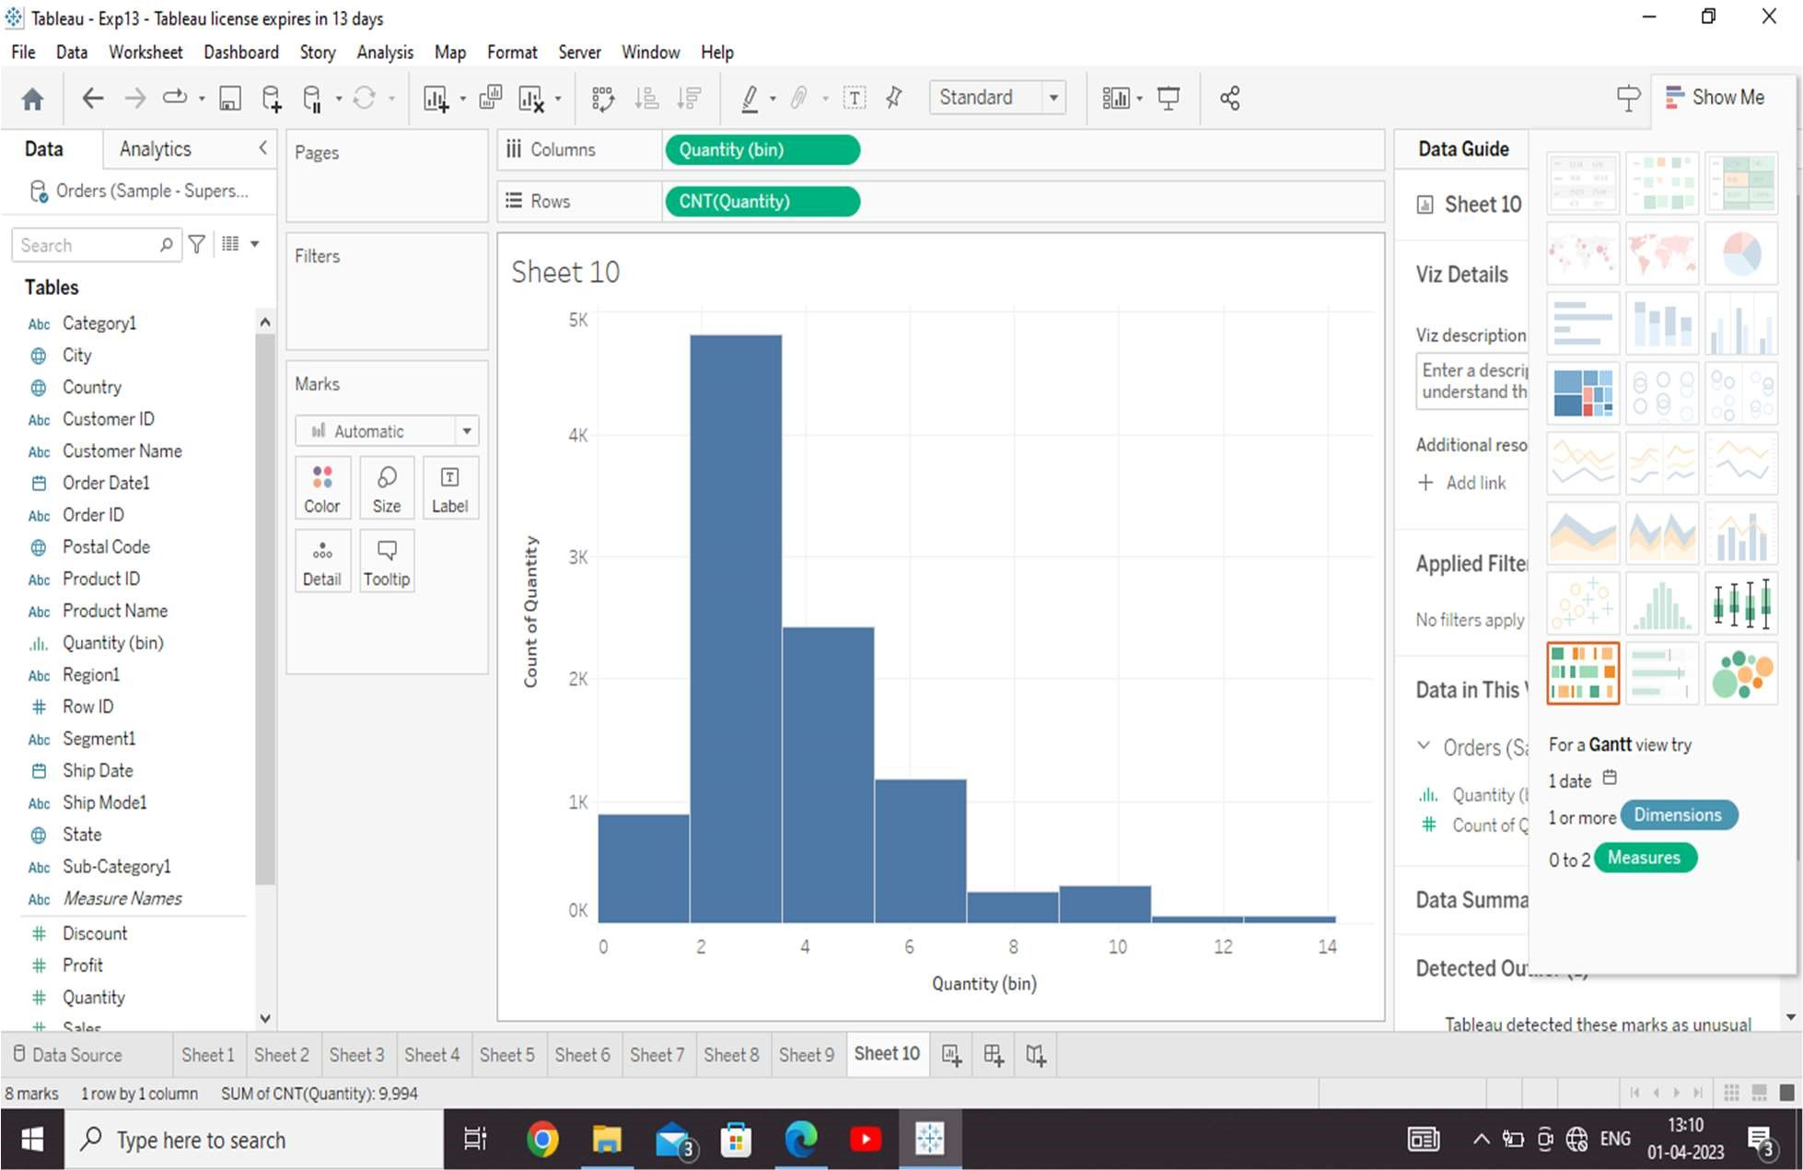

Histogram with Dimension

